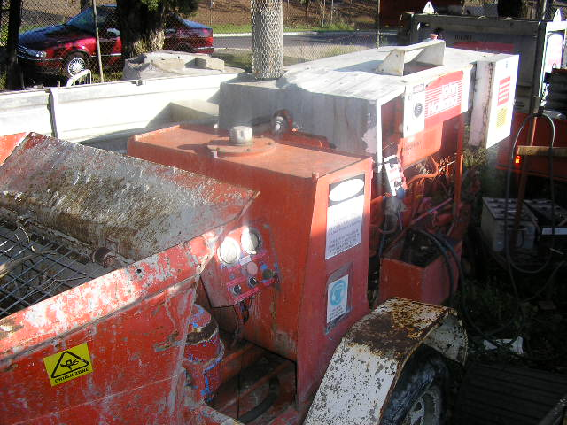 | Hazard Information Sheet
  Equipment: | Concrete and Masonry
 | Equip Type: | Pump
 | Generic Description or  Specific Make / Model: | Concrete Pump
 | Type: | Diesel
 | Other Details

Operator Requirements: | Operators must be trained and competent to use this equipment safely.
Purpose For Which This Equip Is Designed: | For large concreting jobs including foundations and slabs.

Hazards & Risks:
Control Measures:
Entanglement (Guarding):  Becoming entangled in moving parts. | (i) Always stop mixer before removing guard/canopy.  (ii) Don’t operate mixer with guard/canopy removed.  (iii) Barricade off/designate work area.  (iv) Adopt appropriate dress.
High Temperature or Fire:  Refuelling: When refuelling, sparks, flames, hot engine can ignite fuel. | Before refuelling, operator to shut down engine. When refuelling ensure that there are no naked flames in the area.  DO NOT SMOKE. Avoid spilling fuel and collect any fuel run off.
Coming into contact with hot parts. | Keep clear of engine and exhaust outlet.
Noise:  Exposure to noise. | Personnel working with or in the vicinity of this equipment to wear suitable hearing protection.
Suffocation:  Use in a confined space can cause asphyxiation. | Operator/user responsible to use machine in well ventilated area.
Exposure to fumes. | If working in poorly ventilated areas monitor exhaust fumes at regular intervals.

Disclaimer: In fulfilment of its statutory obligations, (ARS) & John Holland has taken what it considers to be all reasonable precautions and exercised due diligence to ensure that it has provided all relevant information on the safe use of the plant. However, except as required by law and only to the extent so required, (ARS) & John Holland does not make any representation, warranty or undertaking, express or implied, as to, or accept any responsibility or liability for, the accuracy or completeness of, or any errors in or omissions from, this Hazard Information Sheet. Except as required by law and only to the extent so required, neither (ARS) & John Holland nor any of its respective directors, officers, agents, or employees shall in any way be liable directly or indirectly to any person or body for any loss or damages, costs or expenses whatever arising out of or in connection with the information contained in this Hazard Information Sheet. | Date: 19/06/06

